AA 203 Problem Set 7

Somrita Banerjee

**Problem 1**

We see that the MPC controller solution cost comes close to the infinite horizon solution cost. On the other hand, the finite horizon cost can be significantly higher, especially when we only predict out to shorter horizons.

In addition, we can see that the evolution of state and control in the MPC case is much closer to the optimal (infinite horizon) case as compared to the finite horizon case.

**Problem 2**

**Part a**

See code for implementation of the receding horizon controller with a terminal cost and a calculation horizon of 50.

**Part b**

These trajectories match the ones in the book. The trajectory starting from [-4.5,2] converges to the origin and the trajectory starting from [-4.5,3] is infeasible after 5 steps.

**Part c**

I discretized the state space with 100 points, 10 along each dimension x1 and x2.

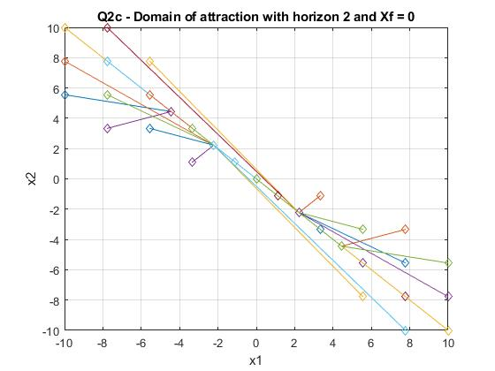

Domain of attraction: Points close to the line joining (-10,10) to (10,-10) that can **reach the origin in exactly 2 time steps**. In particular, points in the regions $\{x_{1}<0, x_{2}>-x_{1}\}$ and $\{x_{1}>0, x_{2}<-x_{1}\}$ are roughly in the domain of attraction.

**Part d**

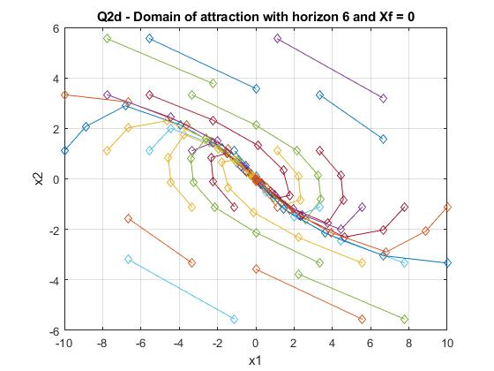

Domain of attraction: Slightly wider range of points close to origin that **can reach the origin in exactly 6 time steps**. The domain of attraction is this spiral region or polygon roughly bounded by $x_{2}=4$, $x_{2}=-4$, ${ x}_{2}=-x_{1} -2$, and $x_{2}=-x_{1}+2$.

**Part e**

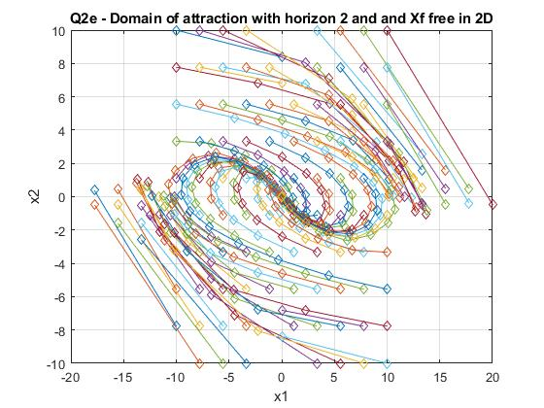

Domain of attraction: This is a much larger range of points close to origin in a spiral of radius approximately 5.

**Part f**

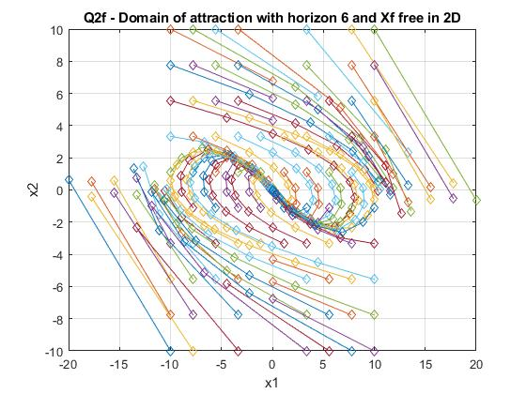

Domain of attraction: This is approximately the same range of points in a spiral of radius approximately 5.

**Part g**

Forcing the terminal state to be exactly the origin imposes a much stricter constraint on the MPC problem and results in fewer starting points that will converge to a solution. If we relax the terminal state to be all of the $R^{2}$ space, the domain of attraction gets bigger because the points no longer have to be exactly at the origin in only 2 or 6 timesteps. If the terminal state has to be exactly 0, changing the MPC horizon from 2 to 6 also increases the domain of attraction.

**Part h**

I used the initial point [-1,1] because I knew that it could easily converge to the origin (which is the terminal set) in as few as 2 time steps.

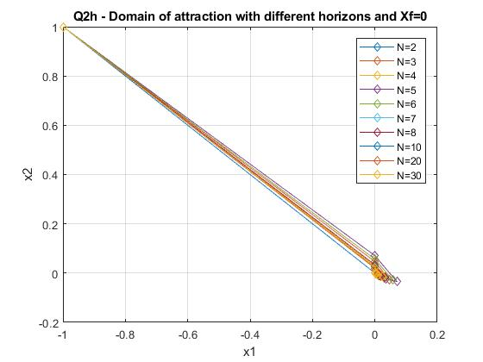

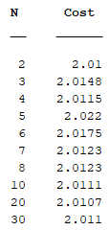

The choice of N keeps both the trajectory and the costs approximately the same.

**Problem 3**

This is the invariant set for the problem. See code attached.

**Problem 4**

**Question 1**

Here the eigenvalues of A are {0.99, 0.99} so A is asymptotically stable.

We can choose $Χ_{f}$ to be the maximally positive invariant set $Ο_{∞}$ for the system $x\left(t+1\right)=Ax\left(t\right)$ which is also a control invariant set for $x\left(t+1\right)=Ax\left(t\right)+Bu(t)$ because $u\left(t\right)$ can be 0. Using MPT, we can simply calculate the maximal control invariant set for $x\left(t+1\right)=Ax\left(t\right)+Bu(t)$ directly.

We choose P such that $-P+Q+A^{'}PA=0$, i.e. solution to the Lyapunov equation. This is solved in MATLAB using P = dlyap(A’,Q).

We get that

P =

1.0e+05 *

0.0005 0.0250

0.0250 2.5131

The invariant set $Χ_{f}$ is plotted below.

**Question 2**

This is for the online controller.

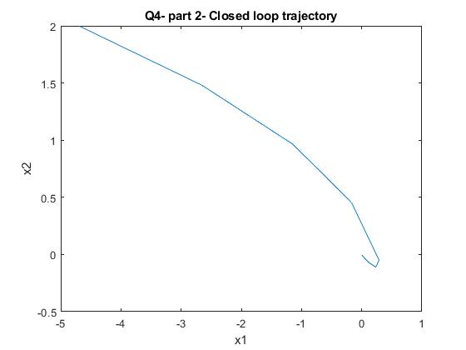

**Question 3**

This is for the explicit controller.

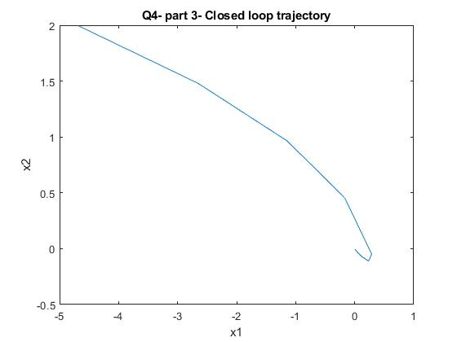

**Question 4**

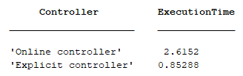

Note that this table includes the time to set up the LTI system, create the MPC controller, and time required to compute closed-loop trajectory. The explicit controller is clearly much faster at computing the closed-loop trajectory, as we would expect.

**Question 5**

This partition shows the regions of the state space where the optimal control law is affine.

